<http://www.work.caltech.edu/~htlin/publication/doc/infkernel.pdf?fbclid=IwAR0y3-BpeP3_nwaz9tLFtJZh3-XiGTFv7M9CvkurYlgkj_MQbJx9tWfav54>

<https://pouannes.github.io/blog/initialization/?fbclid=IwAR1JtHrBBNL68MnBHFQ4its6vNzb1kKoNsCVG8pu9IVdqq-rFHZY7tG8WPU>

<http://d2l.ai/chapter_multilayer-perceptrons/numerical-stability-and-init.html?fbclid=IwAR11jhydSiNDLjKGn3euWHVlRtku39han8rJd9iimJCUbmVhlBoxZChdLn8>

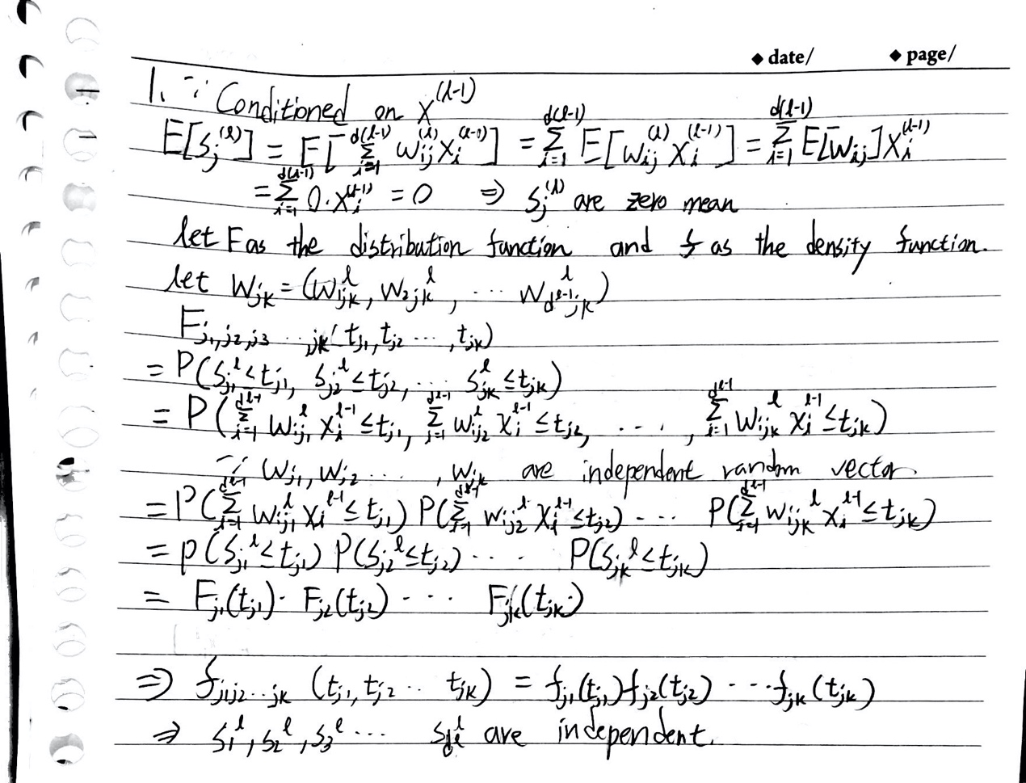

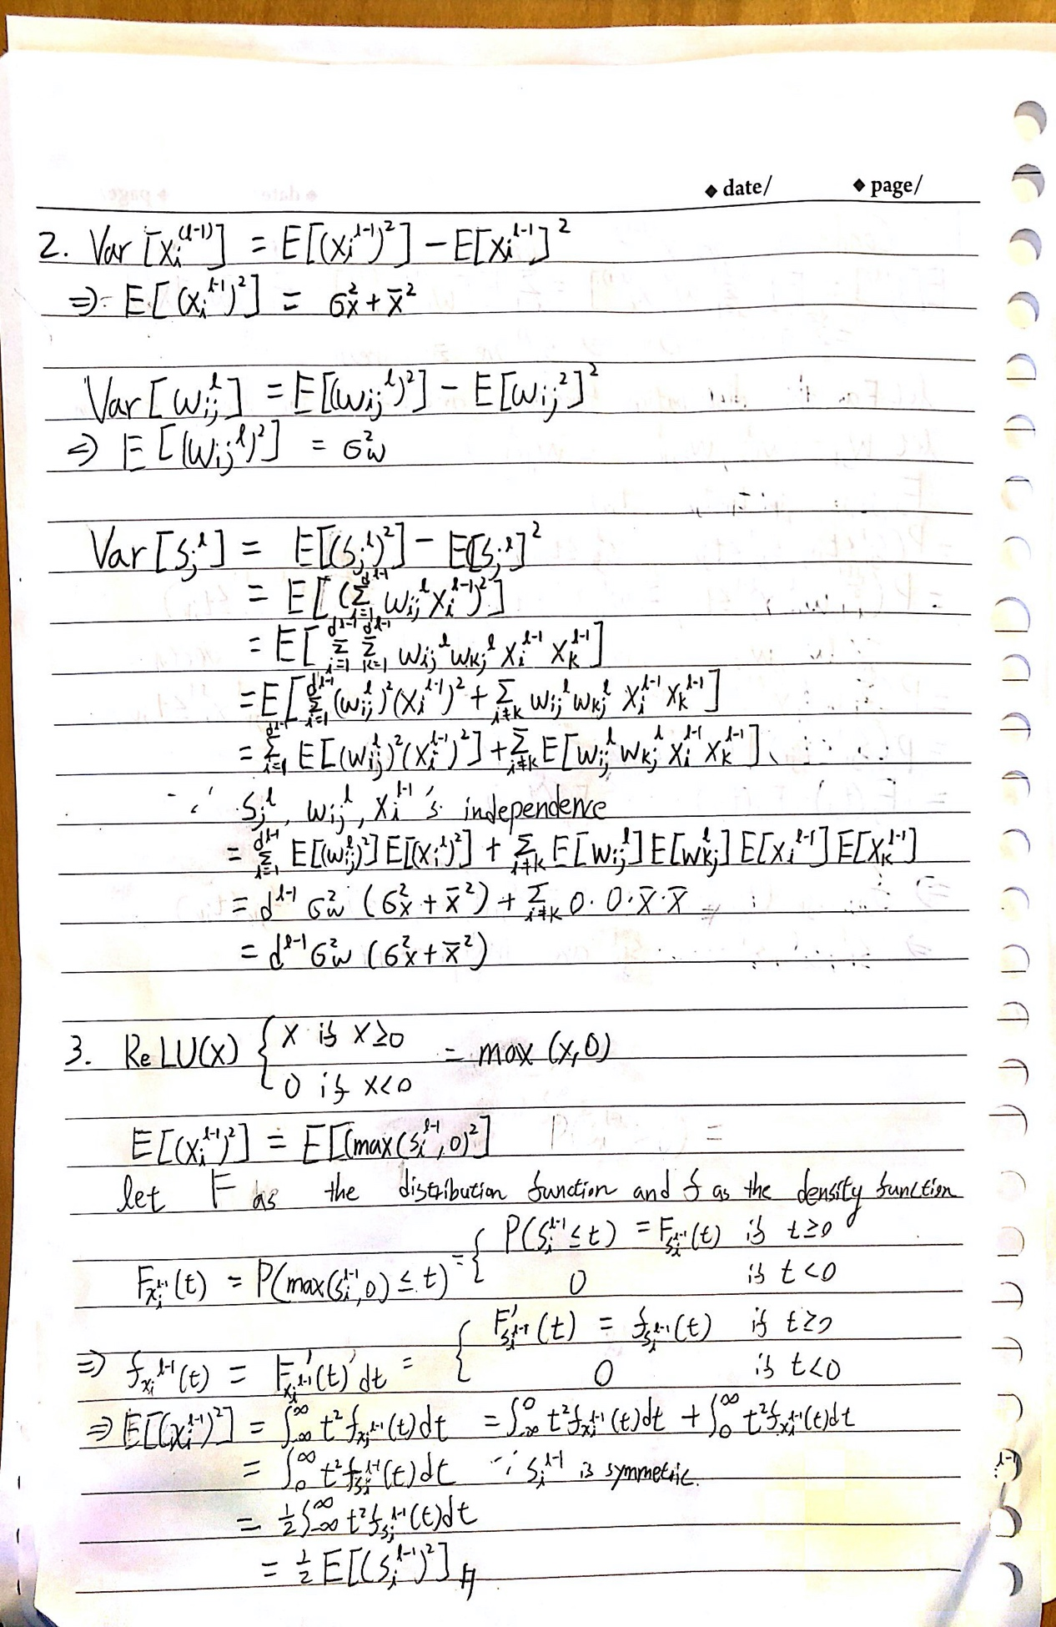

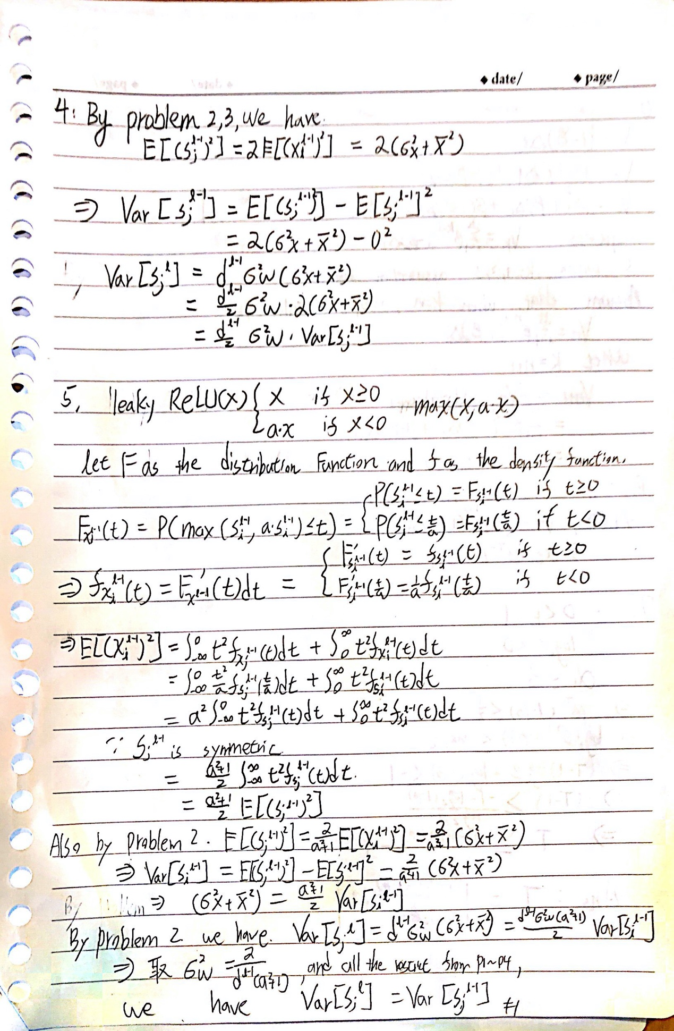

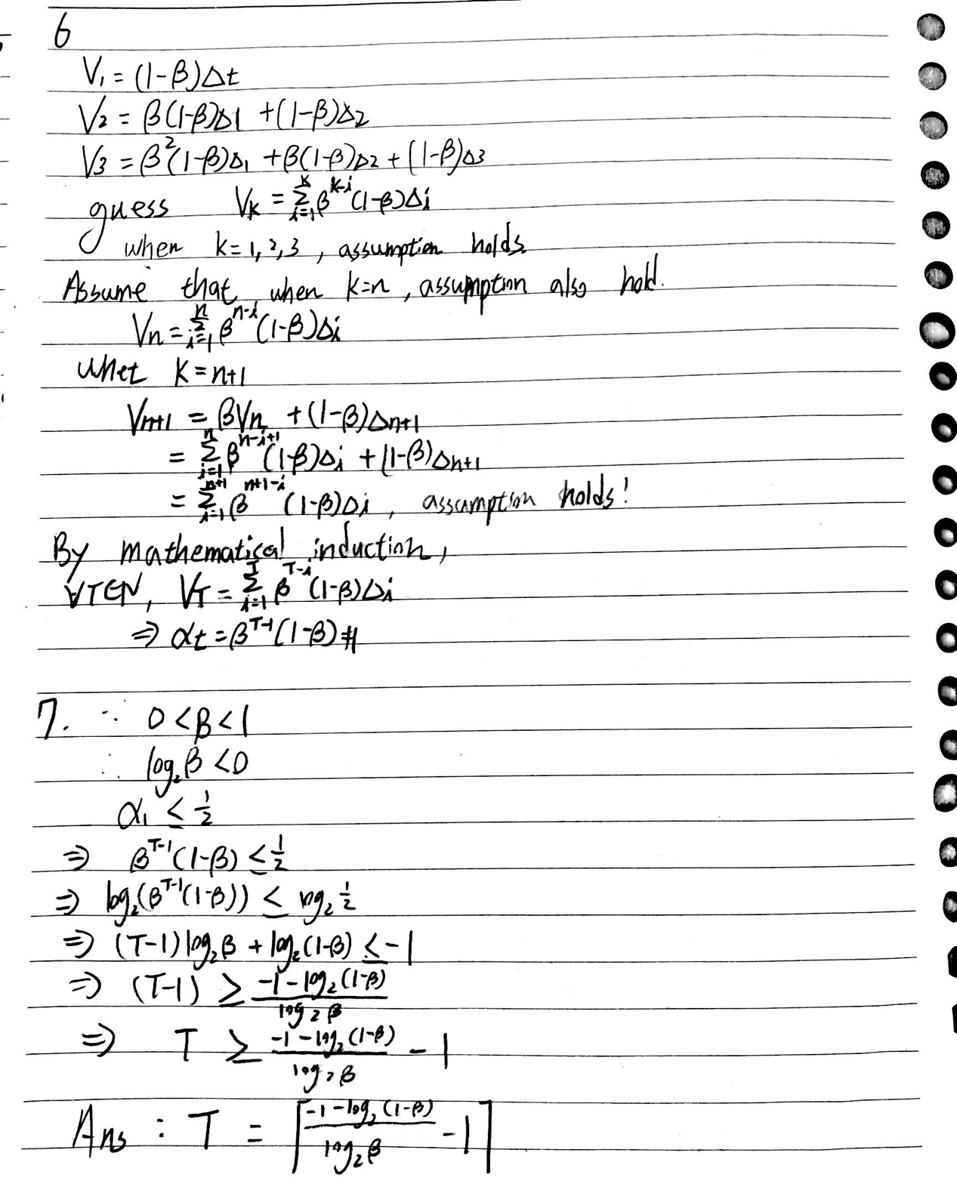

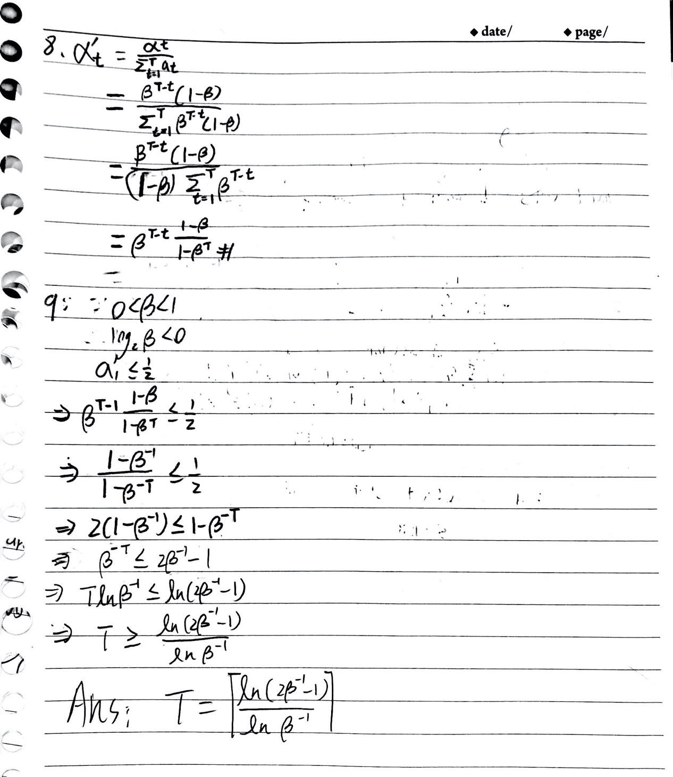

10.

